2. Chebyshev IIR Filter
2.2. Design and Performance Evaluation of a Chebyshev Type-I IIR High-Pass Filter

Program (MATLAB Code)
clc;
clear;
close all;
% Specifications
Rp = 1; % Passband Ripple (dB)
Rs = 40; % Stopband Attenuation (dB)
Wp = 0.5; % Passband Edge
Ws = 0.35; % Stopband Edge
% Find Filter Order
[n,Wn] = cheb1ord(Wp,Ws,Rp,Rs);
% Design High-Pass Filter
[b,a] = cheby1(n,Rp,Wn,'high');
% Frequency Response
figure;
freqz(b,a);
title('Frequency Response');
% Impulse Response
figure;
impz(b,a);
title('Impulse Response');
% Group Delay
figure;
grpdelay(b,a);
title('Group Delay');
% Pole-Zero Plot
figure;
zplane(b,a);
title('Pole-Zero Plot');
fprintf('Filter Order = %d\n',n);
fprintf('Cutoff Frequency = %.4f\n',Wn);
OUTPUT
Filter Order = 6
Cutoff Frequency = 0.5000

Fig 1
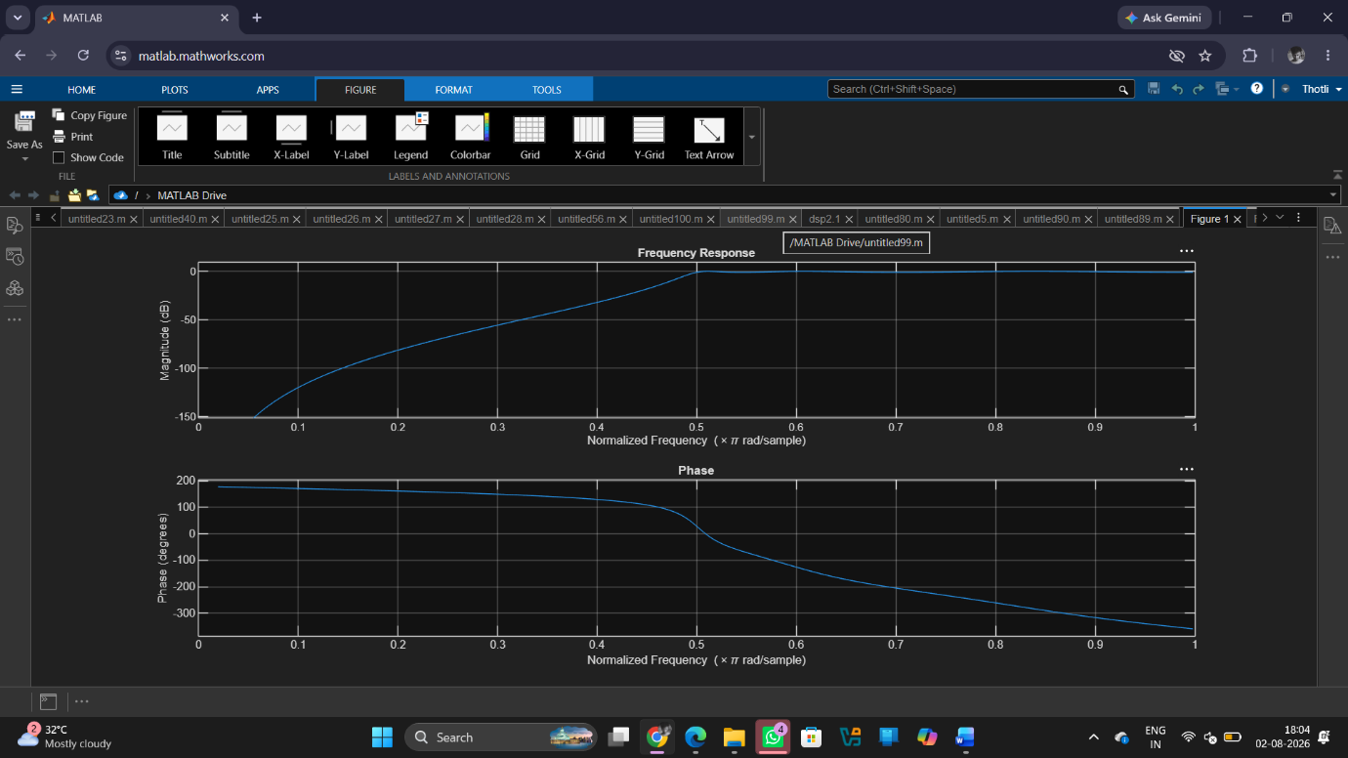

Fig 2
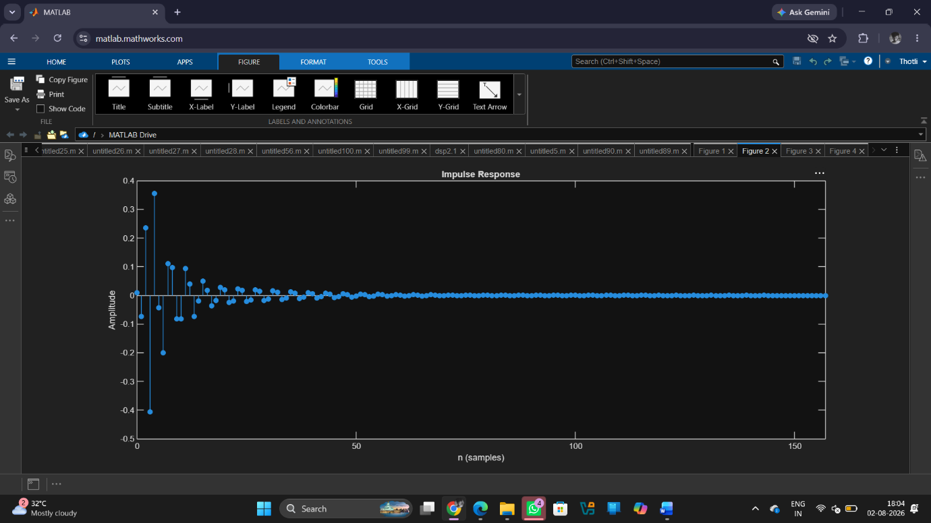

Fig 3
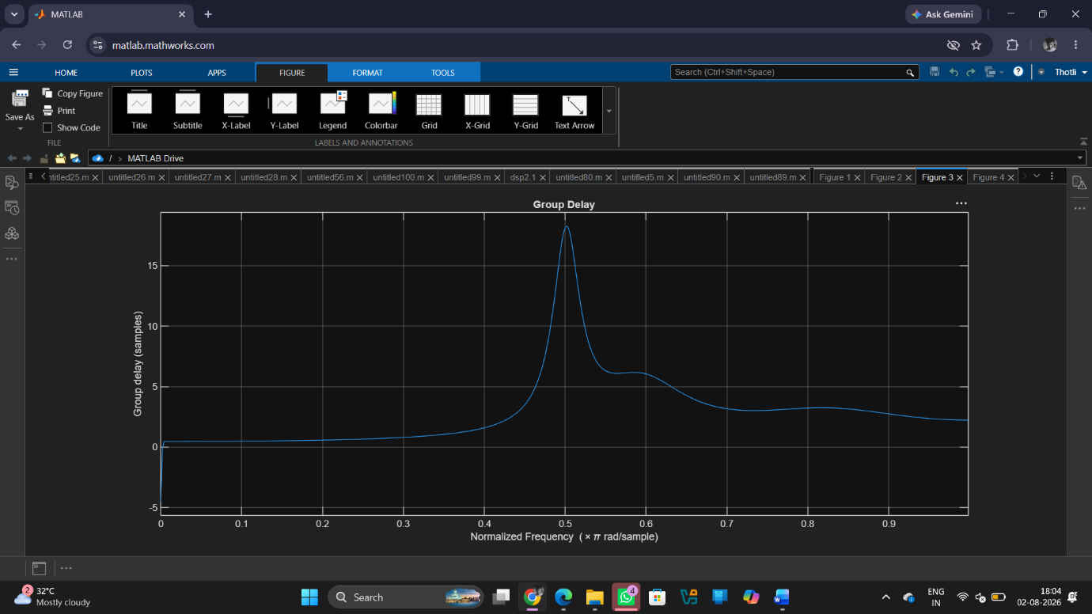

Fig 4
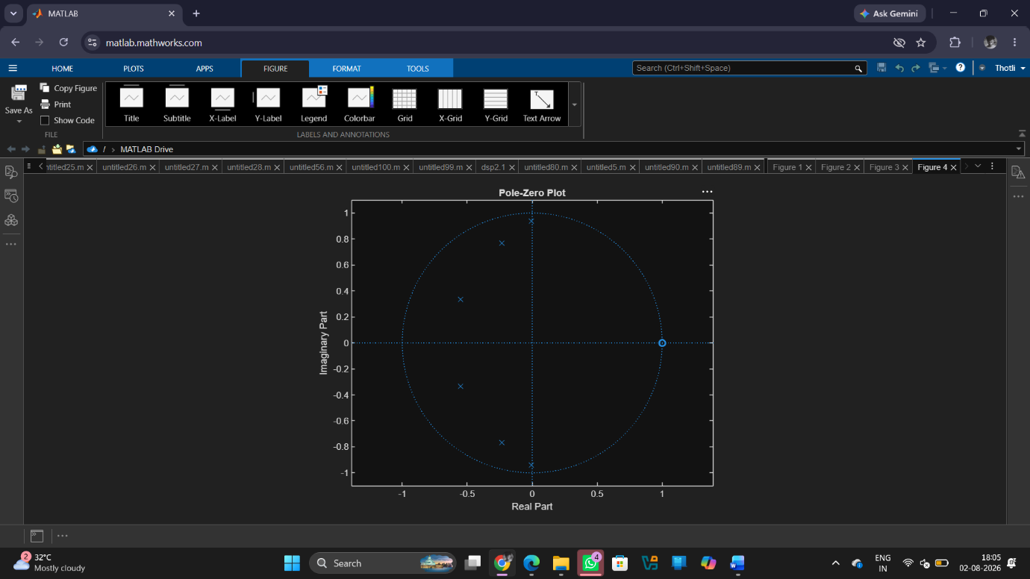
Result:
1. The Chebyshev Type-I IIR High-pass filter was successfully designed, and its magnitude response, phase response, impulse response, and group delay were analysed.
2. The impulse response and group delay characteristics were obtained and found to satisfy the given specifications.
3. The pole-zero plot confirmed that all poles lie inside the unit circle, verifying the stability and proper performance of the filter.
4. The minimum filter order and cutoff frequency were successfully determined and found to satisfy the given design specifications.

